Title of the Article (Times New Roman 14 pts)

First name Surname1, First name Surname2

Abstract
The abstract should be no longer than 15 lines.

Key words
Keyword1, Keyword2, Keyword3, (max. 6 keywords)

JEL classification
JEL Code1, JEL Code2 (max. 3): www.aeaweb.org/jel/guide/jel.php

Introduction (automatically numbered, Spacing: Before: 12 pts, After: 6 pts)
Paragraphs of the text have initial indentation of 1 cm. The manuscript should meet the following requirements:
- A4 sized paper should be used
- Margins: left – 25 mm, right – 25 mm, top – 25 mm, bottom – 25 mm,
- Font size: Main body text – 12 points,
- Line spacing – 1,
- Spacing: Before: 0, After: 0,
- Alignment: Justified,
- Indentation: Left: 0, Right: 0, Special: 0,
- References in text should have this form: (surname, year) (Friedman, 1970).

Do not leave empty line after each part of the article.

Title of the section (automatically numbered, Spacing: Before: 12 pts, After: 6 pts)
Please, use the instructions mentioned in „Introduction“.

Equations have to be centred and right-numbered continuously inside the parenthesis (If equations are not referenced in the text, numbering is not obligatory. Please use 12pt sized font. For writing equations, use a generator of equations). Leave an empty line before and after each equation.

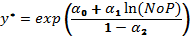 (1)

Tables have to be centred, numbered continuously, and referenced in the text. Please, use the format as given here. Tables should not be wider than the margins of the paper. Leave an empty line before and after each table.

Table 1: Title of the Table (Times New Roman 12 pts, Italic, centred)
Testing Global Null Hypothesis: BETA = 0
 | SR |  |  | PL
Test | Chi-Square | DF | Pr > ChiSq | Chi-Square | DF | Pr > ChiSq
Likelihood Ratio | 810.1 | 26 | <.0001 | 2098.4 | 28 | <.0001
Score | 816.7 | 26 | <.0001 | 1954.3 | 28 | <.0001
Wald | 654.7 | 26 | <.0001 | 1600.7 | 28 | <.0001
Source: ...... (Times New Roman 10 pts, centred)

Figures have to be centred, numbered continuously, and referenced in the text. Please, use the format as given here. Tables should not be wider than the margins of the paper. Leave an empty line before and after each table.

Fig. 1: Title (Times New Roman 12 pts, Italic, centred)
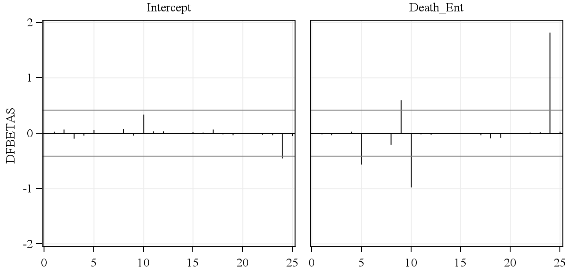
Source: ...... (Times New Roman 10 pts, centred)

Title of the section (automatically numbered, Spacing: Before: 12 pts, After: 6 pts)
Please, use the instructions mentioned above.

Conclusion
This section should include the conclusions of the article. Please, follow all the instructions for writing articles.

Acknowledgements
Supporting people and institutions (including Science Foundations) go here.
References
References should be alphabetically sorted and follow the introduced style. All references must meet APA styles (http://www.apastyle.org/). You can use option in the Google Scholar – write the title of the paper (or/and names of authors) and next choose APA format– (please, check if all the numbers i.e. pages number and volume number are correct).
automatic APA citation maker.
(http://citationmachine.net/index2.php?reqstyleid=2&newstyle=2&stylebox=2).

Corresponding author: University/Institute, Faculty, Department, Address, E-mail. (Times New Roman 10 pts)
University/Institute, Faculty, Department, Address, E-mail.

