Title of the Article (Times New Roman 14 pts)

First name Surname1, First name Surname2

Abstract
The abstract should be no longer than 10 lines.

Key words
Keyword1, Keyword2, Keyword3, (max. 5 keywords)

JEL classification
JEL Code1, JEL Code2 (max. 3): www.aeaweb.org/jel/guide/jel.php

Introduction (automatically numbered, Spacing: Before: 12 pts, After: 6 pts)
Paragraphs of the text have initial indentation of 1 cm. The manuscript should meet the following requirements:
- Submit papers of no more than 6-10 pages,
- A4 sized paper should be used,
- Margins: left – 25 mm, right – 25 mm, top – 25 mm, bottom – 25 mm,
- Font size: Main body text – 12 points,
- Line spacing – 1,
- Spacing: Before: 0, After: 0,
- Alignment: Justified,
- Indentation: Left: 0, Right: 0, Special: 0,
- References in text should have this form: (surname, year) (Friedman, 1970).

Do not leave empty line after each part of the article.

Title of the section (automatically numbered, Spacing: Before: 12 pts, After: 6 pts)
Please, use the instructions mentioned in „Introduction“.

Equations have to be centred and right-numbered continuously inside the parenthesis (If equations are not referenced in the text, numbering is not obligatory. Please use 12pt sized font. For writing equations, use a generator of equations). Leave an empty line before and after each equation.

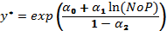 (1)

Tables have to be centred, numbered continuously, and referenced in the text. Please, use the format as given here. Tables should not be wider than the margins of the paper. Leave an empty line before and after each table.
Table 1: Title of the Table (Times New Roman 12 pts, Italic, centred)
Testing Global Null Hypothesis: BETA = 0
 | SR |  |  | PL
Test | Chi-Square | DF | Pr > ChiSq | Chi-Square | DF | Pr > ChiSq
Likelihood Ratio | 810.1 | 26 | <.0001 | 2098.4 | 28 | <.0001
Score | 816.7 | 26 | <.0001 | 1954.3 | 28 | <.0001
Wald | 654.7 | 26 | <.0001 | 1600.7 | 28 | <.0001
Source: ...... (Times New Roman 10 pts, centred)

Figures have to be centred, numbered continuously, and referenced in the text. Please, use the format as given here. Tables should not be wider than the margins of the paper. Leave an empty line before and after each table.

Fig. 1: Title (Times New Roman 12 pts, Italic, centred)
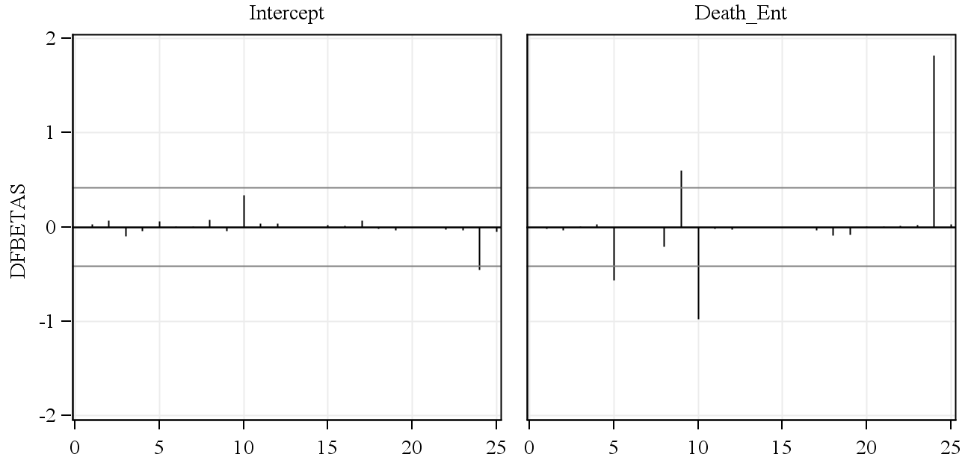
Source: ...... (Times New Roman 10 pts, centred)

Title of the section (automatically numbered, Spacing: Before: 12 pts, After: 6 pts)
Please, use the instructions mentioned above.

Conclusion
This section should include the conclusions of the article. Please, follow all the instructions for writing articles.

Acknowledgements
Supporting people and institutions (including Science Foundations) go here.
References

References that follow have to be alphabetically sorted and should follow the introduced style. All references must meet APA styles (http://www.apastyle.org/)! Automatic citation maker for references: automatic APA citation maker.
(http://citationmachine.net/index2.php?reqstyleid=2&newstyle=2&stylebox=2).

- Barnay, T. (2016). Health, work and working conditions: a review of the European economic literature. The European Journal of Health Economics, 17(6), 693-709. doi:10.1007/s10198-015-0715-8.
- Bartošovič, I. (2016). Some aspects of health status of the Gypsy population in Slovakia. Bratislava Medical Journal - Bratislavské lekárske listy, 117(1), 26-30. doi:10.4149/BLL__2016_006.
- Björnberg, A. (2016, January 26). Euro Health Consumer Index 2015. Retrieved February 8, 2017, from
http://www.healthpowerhouse.com/media/prerelease/EHCI_2015_media.pdf.
- Eurostat. (2013). European Health Interview Survey (EHIS wave 2) - Methodological manual (Working paper No. KS-RA-13-018-EN-N). doi:10.2785/43280.

First name and surname of an author including academic and other titles (e.g. prof. Ing. Peter Novotný, PhD.), University, Faculty, Department, Address, E-mail. (Times New Roman 10 pts)
First name and surname of a co-author including academic and other titles (e.g. doc. RNDr. Anna Novotná, CSc.), University, Faculty, Department, Address, E-mail.

